**Spring**

* Lightweight development with Java POJOS (Plain-Old-Java-Objects)
* Dependency injection to promote loose coupling
* Declarative programming with Aspect-Oriented-Programming (AOP)
* Minimize boilerplate Java code

Core container :

Creating beans and making those beans available

Infrastructure:

AOP - Application wide services like logging security, transaction. These services applied to applications.

Data Access Layer:

JDBC helper class, access database easily

ORM obj to relation mapping

JMS Java msg services for sending async msgs to msg broker

Web Layer:

All web related classes. Home of the spring MVC framework.

Test Layer:

Supports test-driven development (TDD).

**IOC: Inversion of control.**

Outsource to an object factory

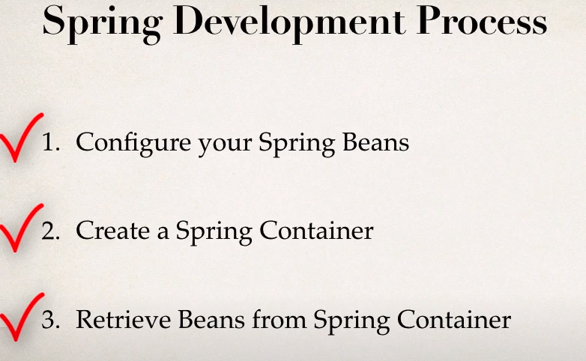

Step 1:

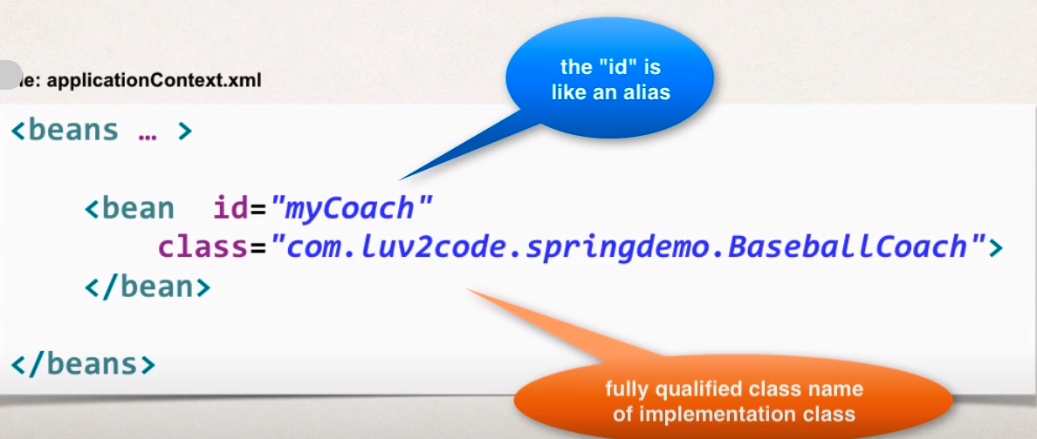

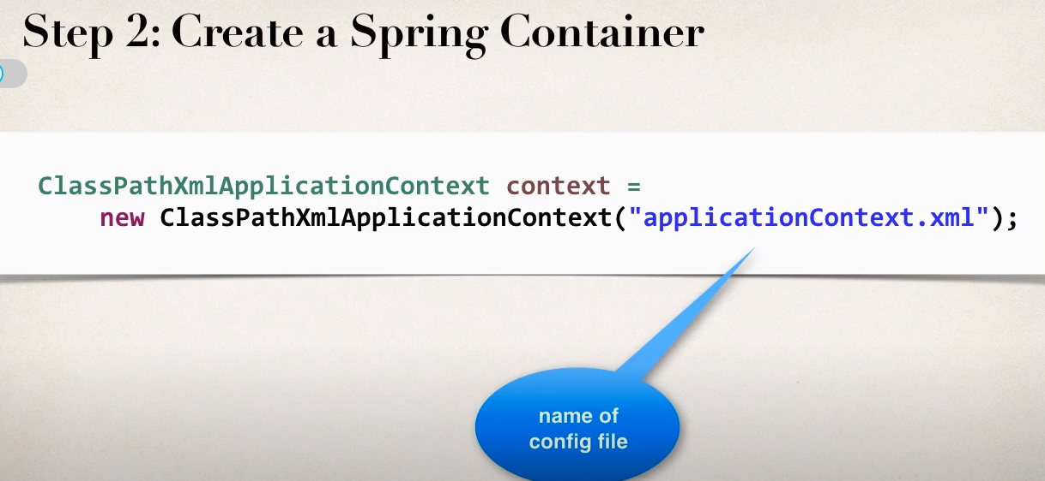

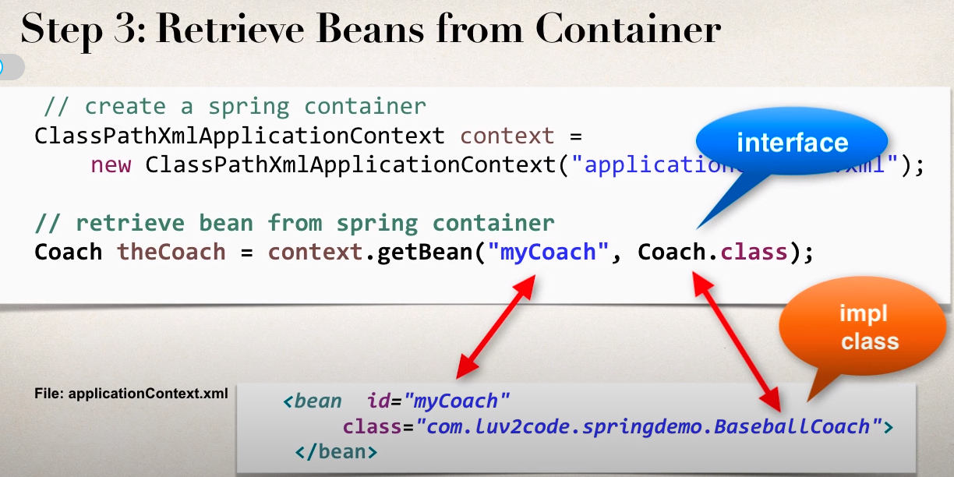

**Dependency Injection**

Principle: The client delegates to calls to another object the responsibility of providing its dependencies.

Injection Types

● Constructor Injection

● Setter Injection

**Development Process - Constructor Injection**

1. Define the dependency interface and class

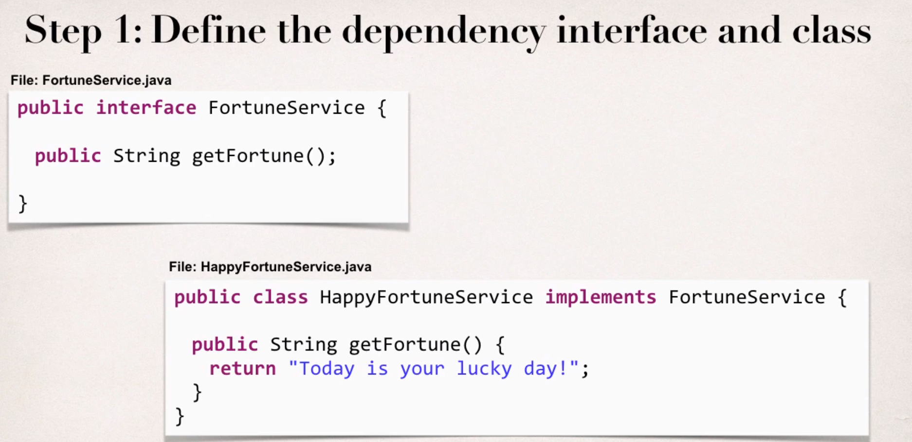

2. Create a constructor in your class for injections

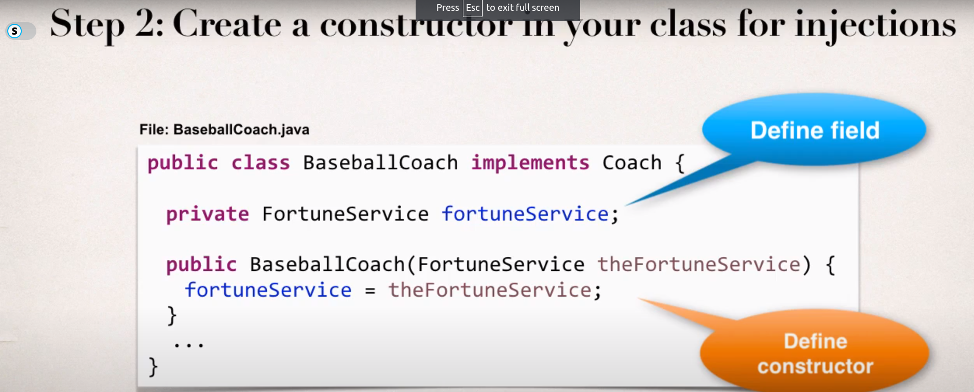

3. Configure the dependency injection in Spring config file

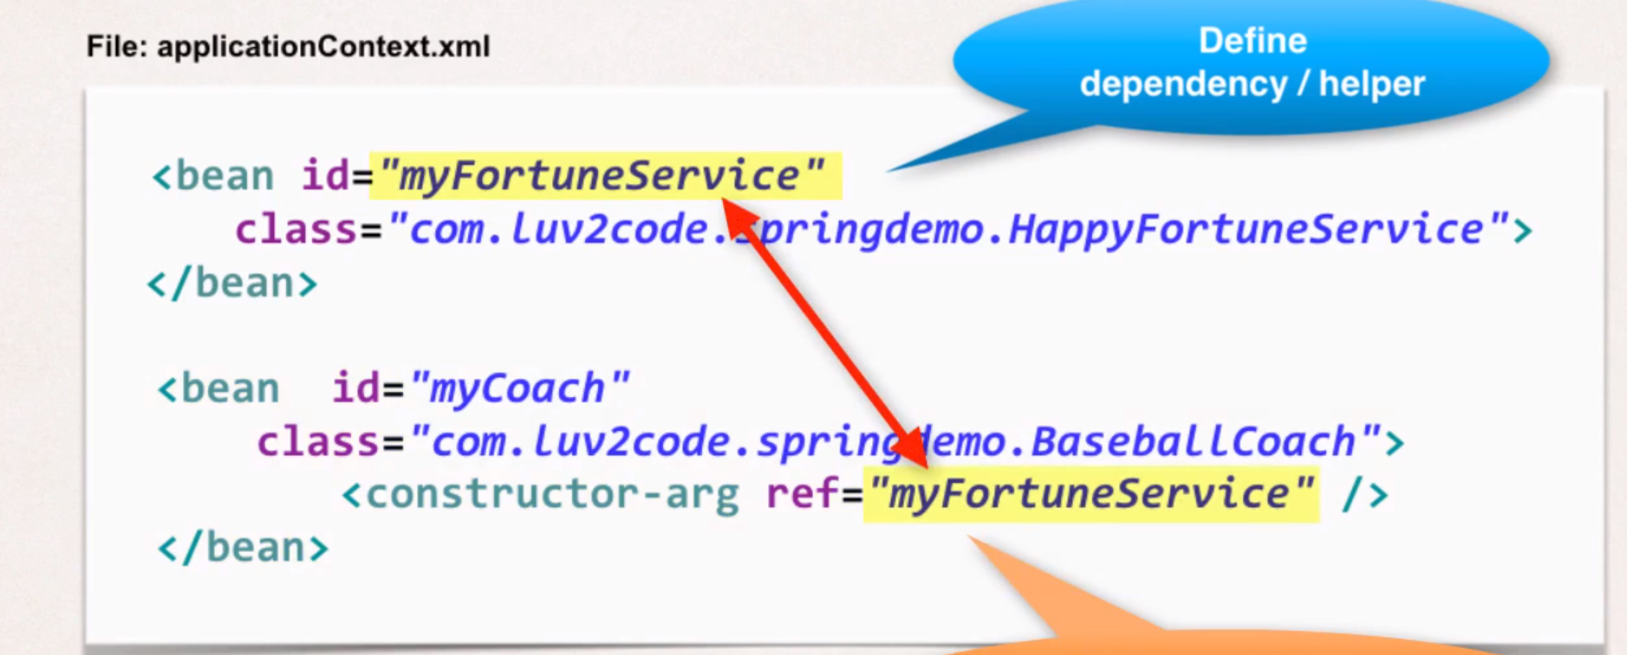

**Development Process - Setter Injection**

1. Create setter method(s)in your class for injections

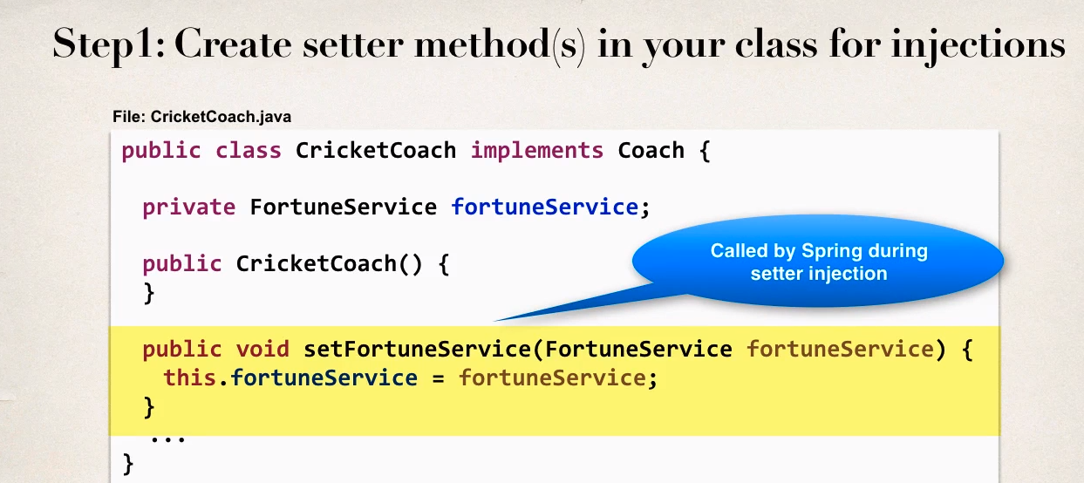

2. Configure the dependency injection in Spring config file

